
Khwaja Yunus Ali Medical College & Hospital
Enayetpur, Chauhali, Sirajganj-6751

Department of Obstetrics & Gynaecology Date: 01/06/2026

Notice
All faculty members, medical officers, and doctors of the Department of Obstetrics & Gynecology are hereby requested to attend the Monthly Departmental Meeting as per the following schedule:
Date: 03.07.26
Time: 9:15 AM
Venue: Class room, Department of Obstetrics & Gynecology

Agenda of the Meeting:
- Review of Ward Activities
- Review of Operation Theatre (OT) Activities
- Review of Labor Room Activities
- Academic Progress and Educational Activities
- Accreditation Workup and Progress Review
- ISO Visit Feedback Issues
- Miscellaneous Issues
Your presence and active participation are highly appreciated for the smooth functioning and development of the department.
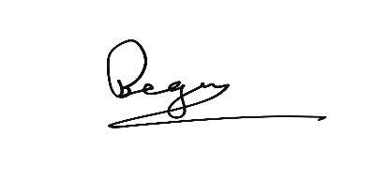
……………………………….
Prof. Dr. Parvin Rahman
Head of Dept. of Obstetrics & Gynaecology
Khwaja Yunus Ali Medical College & Hospital

Copies are forwarded for kind information and necessary action please to:
- Principal, Khwaja Yunus Ali Medical College
- Vice Principal, Khwaja Yunus Ali Medical College
- Academic Coordinator, Phase-IV Coordinator, Khwaja Yunus Ali Medical College
- Medical Education Unit
- Ward In-charge
- OT In-charge
- Notice Board
- Office Copy

